B2024

EEL MQP Updates

**Submitted By:**

Natalie Essig

Christopher Hunt

Pranav Jain

Dexter Stark

Date Submitted and Completed: 12/13/24

Project Advisors: Robin Hall, Professor Onal

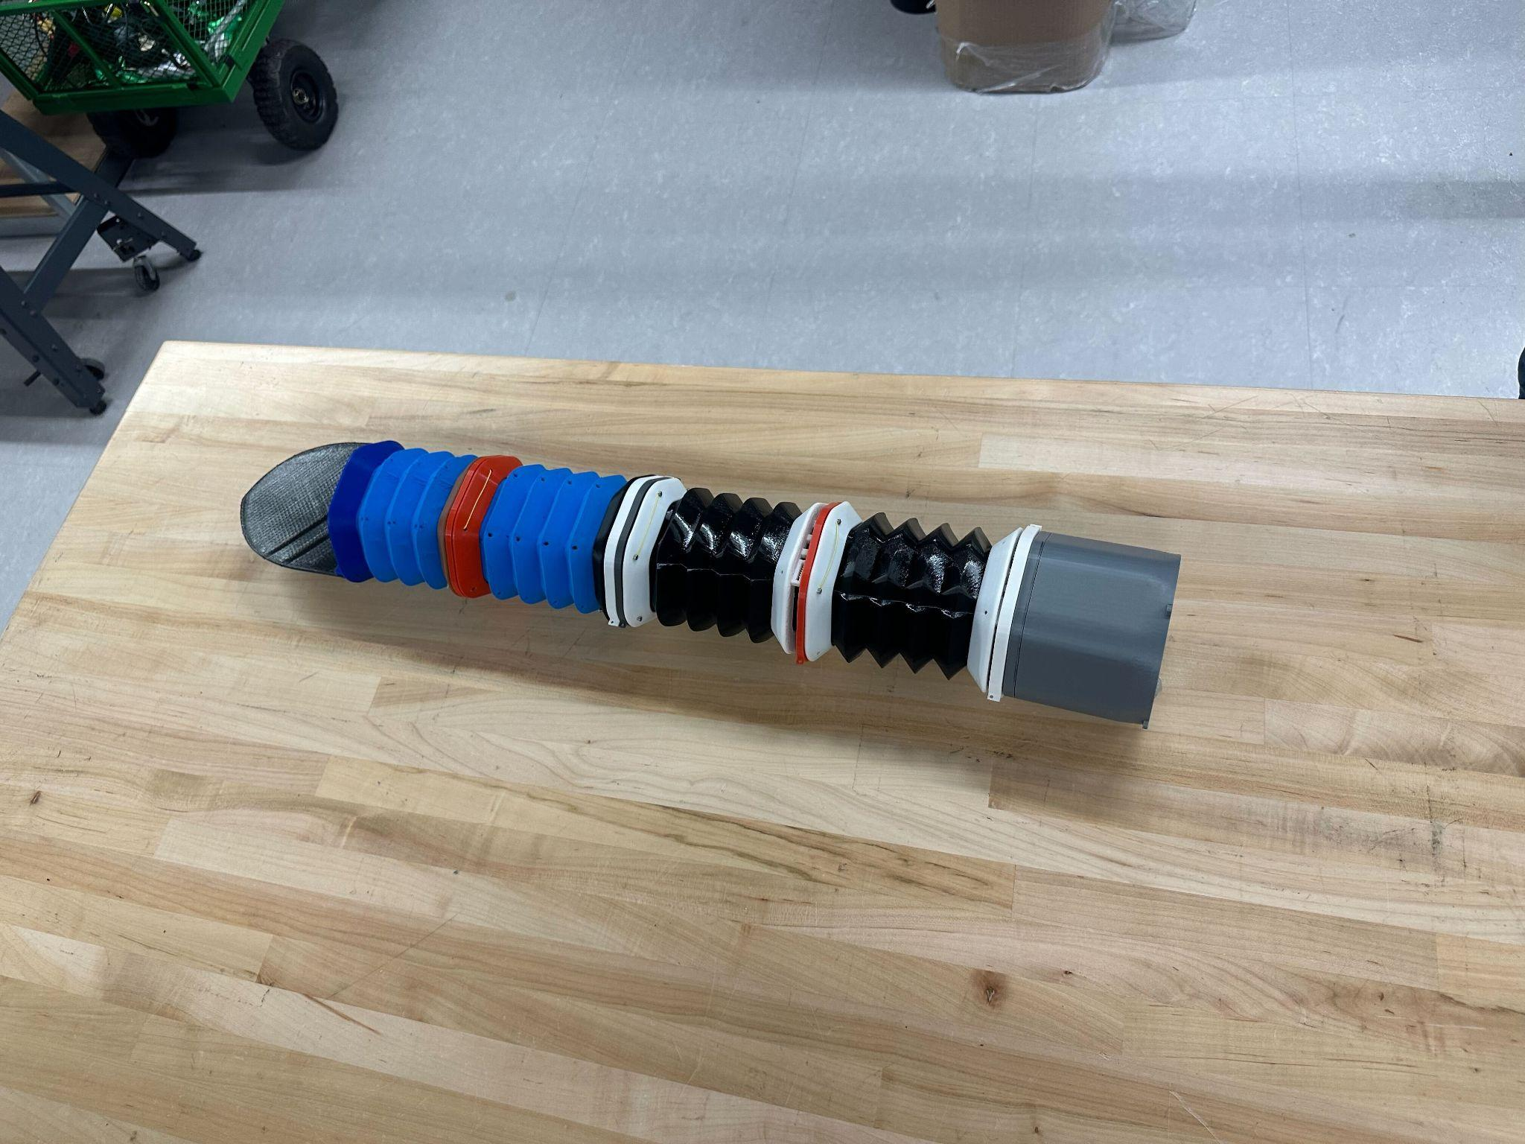

# Chris:

**Accordion bend**

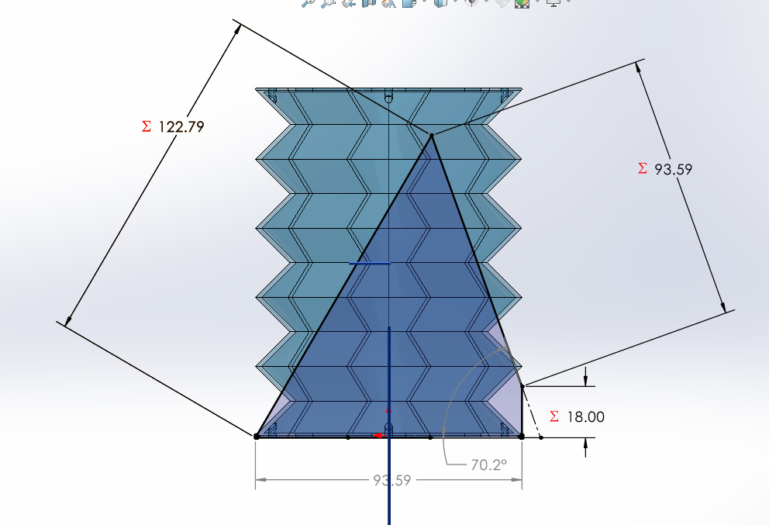

Devised a system of estimating accordion bend angle:

Operated under the following inaccurate assumptions to simplify the geometry:

* The uncompressed side has a fixed length
* The folds on the compressed side collapse on each other but they do not compress further than the thickness the material was printed at

This means that this is not an accurate estimate, but is a fast and easy way of determining numerically how much better specific design modifications are in terms of bend angle.

The compressed height is calculated using the number of ridges (see figure C.1), + 2 to account for the top and bottom folds (see figure C.2), * 2 * the thickness of each fold, ie if all of the folds were stacked on top of each other, what would the height of that be.

Using the calculated uncompressed height, the width of the shorter side, and the estimated compressed height above, the approximate geometry of the accordion when bending is calculated, and the bend angle is measured.

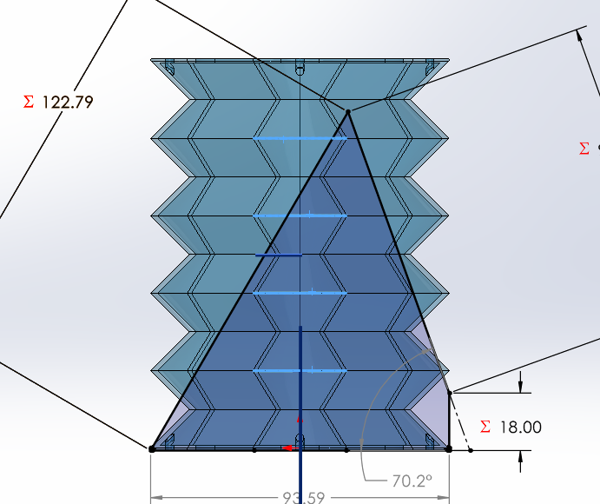

*(Figure C.1: demonstration of what “ridges” refers to)*

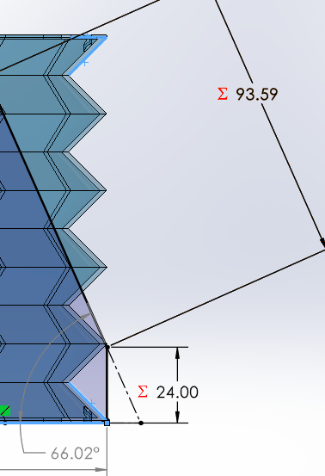

*(Figure C.2: demonstration of top and bottom folds)*

From this model, the following relationships between bend angle and other geometry can be inferred:

* Larger ratio between uncompressed and compressed sides->larger bend angle
  + Longer uncompressed height -> larger bend angle
  + Shorter compressed height -> larger bend angle
    - Fewer ridges/folds for same uncompressed height-> larger bend angle
* Shorter base side width -> larger bend angle

Of these, it was determined that it was impractical to adjust the base side width since that would decrease the tube volume and cross-sectional area which was already limiting some of our designs. I decided to increase the total height by 25% from the original design because it resulted in a significant increase from 53.97deg to 70.2deg but we have been having issues with printing the accordion so I didn’t want to increase it any further than that.

This left the primary method of adjusting the bend angle as decreasing the number of ridges. This could be practically achieved in two main ways: increasing the ridge width (see Figure C.4), which subsequently increases the vertical distance covered by each ridge, decreasing the ridges per unit of height, or increasing the ridge angle (see Figure C.5). Decreasing the ridge width had diminishing returns, and eventually ended up decreasing the bend angle at 20mm. The ridge width also decreased the usable volume/cross-section of the tube so 15mm was selected at a nice value that still had significant improvement over 10mm. The original ridge angle we started with was around 30 degrees. This resulted in a significant droop of the part when printing because 3D printers are designed to print at 45-degree angles and higher for overhangs. However, increasing the angle too much negatively impacts the bendability of the accordion, so an angle of 45 deg was selected.

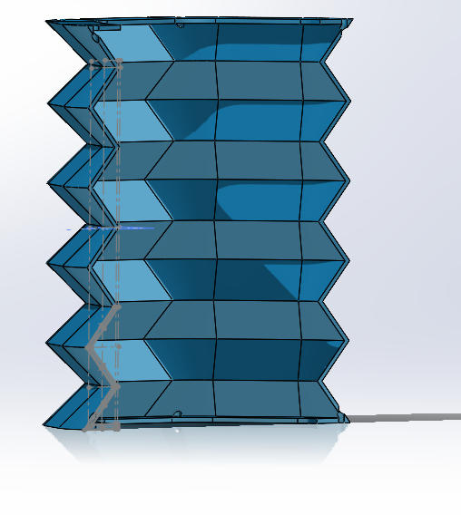

*(Figure C.3: providing context to the bellow sketches)*

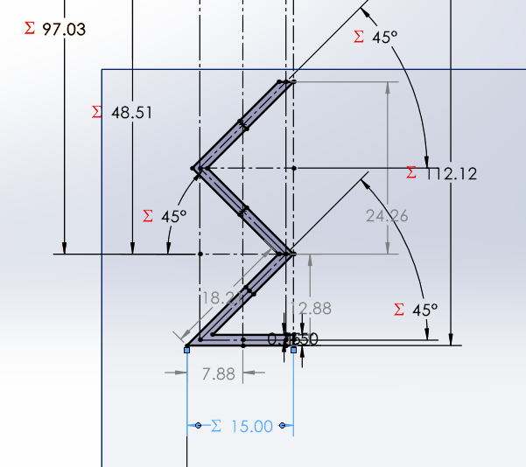

*(Figure C.4: demonstrating what “ridge width” refers to)*

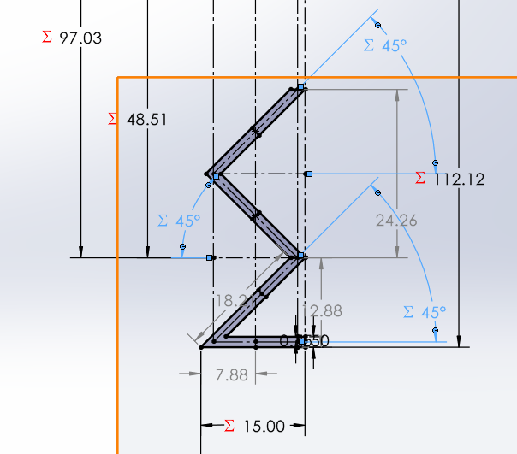

*(Figure C.5: Demonstrating what “ridge angle” refers to)*

The accordion was redesigned by me in the cad so that all of the parameters that can be used to increase bend angel are configurable, with the following iterations:

| Iteration | 0 | 1 | 2 | 3 | 4 |
| --- | --- | --- | --- | --- | --- |
| Hypothetical Bend Angle (deg) | 38.13 | 45.27 | 47.19 | 53.97 | 70.20 |
| Height (mm) | 100 | 100 | 100 | 100 | 125 |
| Ridge width (mm) | 10 | 20 | 15 | 15 | 15 |
| Ridge angle  (degrees) | 30 | 30 | 30 | 45 | 45 |
| Number of middle ridges |  |  |  |  |  |

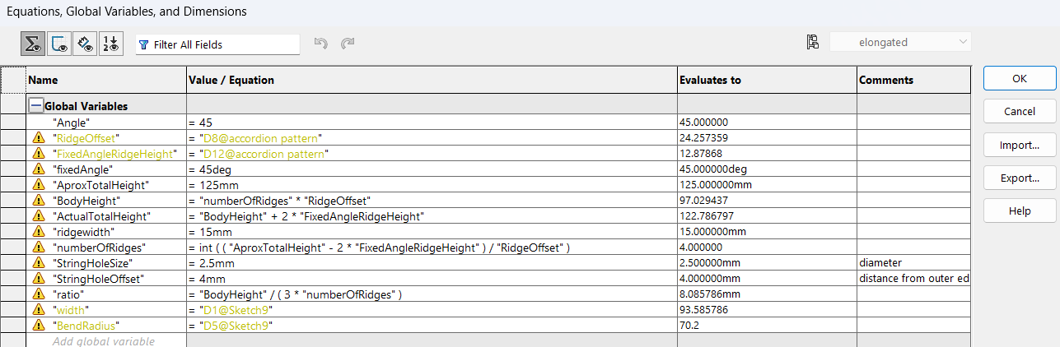

*(Figure C.6: table of parameters for the accordion)*

**PCB**

The PCB for converting from i2c to PWM to allow our modules to be connected serially is currently undergoing its first round of revisions. The initial design was built following the following principles:

* inexpensive parts
* Wanted secure connections
* Rounded corners to potentially fit in a tight tolerance friction fit and prevent cuts when handling.

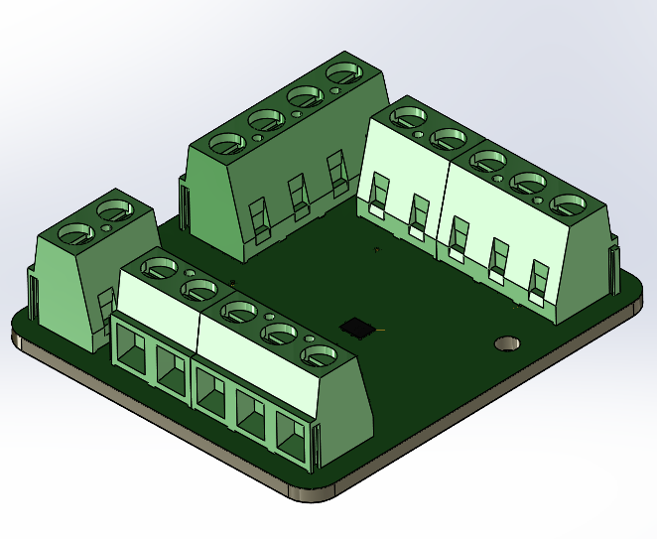

*(C.7: CAD model of the first PCB iteration)*

In order to meet our advisor’s requests for more physical results, this PCB was designed and ordered before the housing or assembly process were developed. Following the development of the housing, and investigations into the assembly methods, the following flaws were determined:

* The board is too tall because of the screw terminals used
  + This creates problems with fitting the housing into the module
* The board is too large in both width and length directions
  + Doesn’t provide sufficient space for wires to bend and limits access to the wires for assembly
* The main chip BGA requires a level of precision for assembly that we are unable to achieve with the equipment on hand
* Traces for motor power are too small
  + Some traces in earlier modules will have the current for all motors in the eel running through them and will need to be significantly larger to handle this

To fix these flaws, the next iteration will be designed using the following strategies:

* Different terminals will be used to prioritize height and hopefully utilize wire connectors the lab has in stock
  + These smaller terminals will both help with height and also width
* If the new connectors are not sufficient for decreasing the width and length, the connectors can be rotated by 45degrees around the center chip to allow for the wire bend radius
* We can have the PCB manufacturer install the BGA for us for relatively minimal cost increase
* The traces will be increased to handle either the stall current of 5 motors, or the max current draw of the battery, whichever value is lower as that will be the limiting factor of the robot.
  + If this results in impractical large traces, a new design, likely involving larger gauge wire and connecting those wires with wire nuts in the housing with the pcb may be utilized

**PCB housing**

The PCB housing 1st iteration was designed with the following features:

* Holes for heat inserts to prevent the use of nuts that require a tiny wrench the lab doesn’t have or hand-tightening
* Greater than 45-degree draft to help with printing with fewer supports
* Tabs to help align easily align the board during assembly
* Built-in standoffs to give clearance for the uneven bottom surface created by through-hole soldered components
* Built-in straight relief (with added clips)
* Tight fit slots for wires (exact size was guessed because the wires hadn’t arrived when this was being designed)
* A face seal with parameters and equations to determine the seal properties (see Figure C.10).
  + Parameters based on these design considerations: <https://www.marcorubber.com/o-ring-groove-design-considerations.htm>
  + Current values

| Design Parameter | Acceptable range | Current value |
| --- | --- | --- |
| Stretch | 0%-5% | 4% |
| Gland Fill | 75% | 80% |
| Compression ratio | 20%-30% | 20% |

* + O-ring crossectional diameter to bend radius ratio
    - <https://www.barnwell.co.uk/can-o-rings-be-used-in-non-circular-groove-patterns/#:~:text=O%20Rings%20To%20Fit%20In%20Non%2DCircular%20Grooves&text=The%20inside%20radius%20should%20be,leakage%20due%20to%20corner%20crease> recommends 1:3-1:6 with closer to 1:6 being ideal
    - Current value 1:3.5

|  |  |
| --- | --- |
| *(Figure C.8: Real image of o-ring seal in PCB housing)* | *(Figure C.9 CAD Modle of o-ring Gland)* |

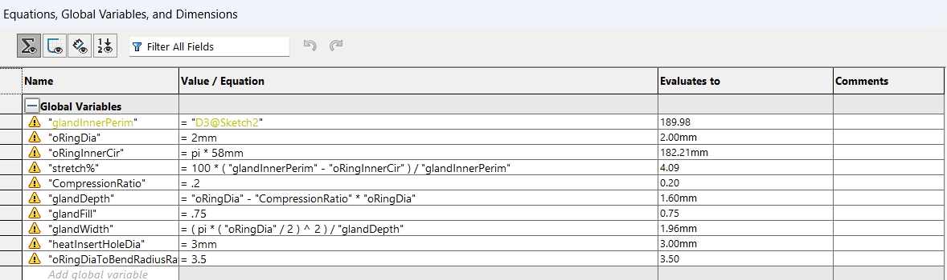

*(Figure C.10: Solidworks Table of parameters for the O-ring and Gland)*

PCB housing waterproof testing:

Test 1

The PCB housing’s waterproofness and seal were tested. The O-ring was placed in the gland in the housing, and the housing was closed with the screws being tightened to “screwdriver” tight. The slots for wires that will be epoxied in the final version were closed up with hot glue. The housing was then placed underwater by hand and observed.

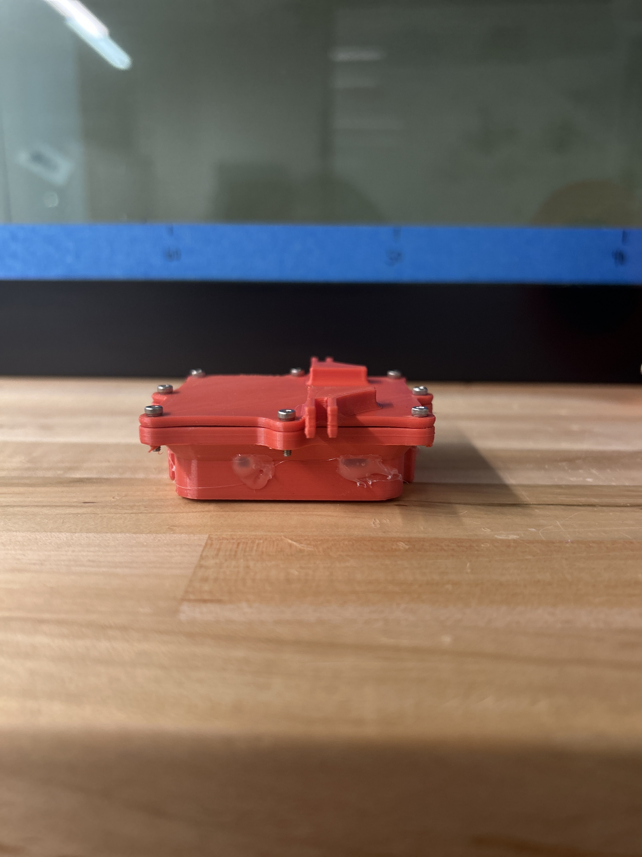

*(Figure C.11: picture of assembled PCB housing prepped for first water test)*

Results:

Failure/inconclusive: bubbles were seen coming from both the hot-glued slots and seal, and when the housing was opened up there was water inside (see Figure C.12)

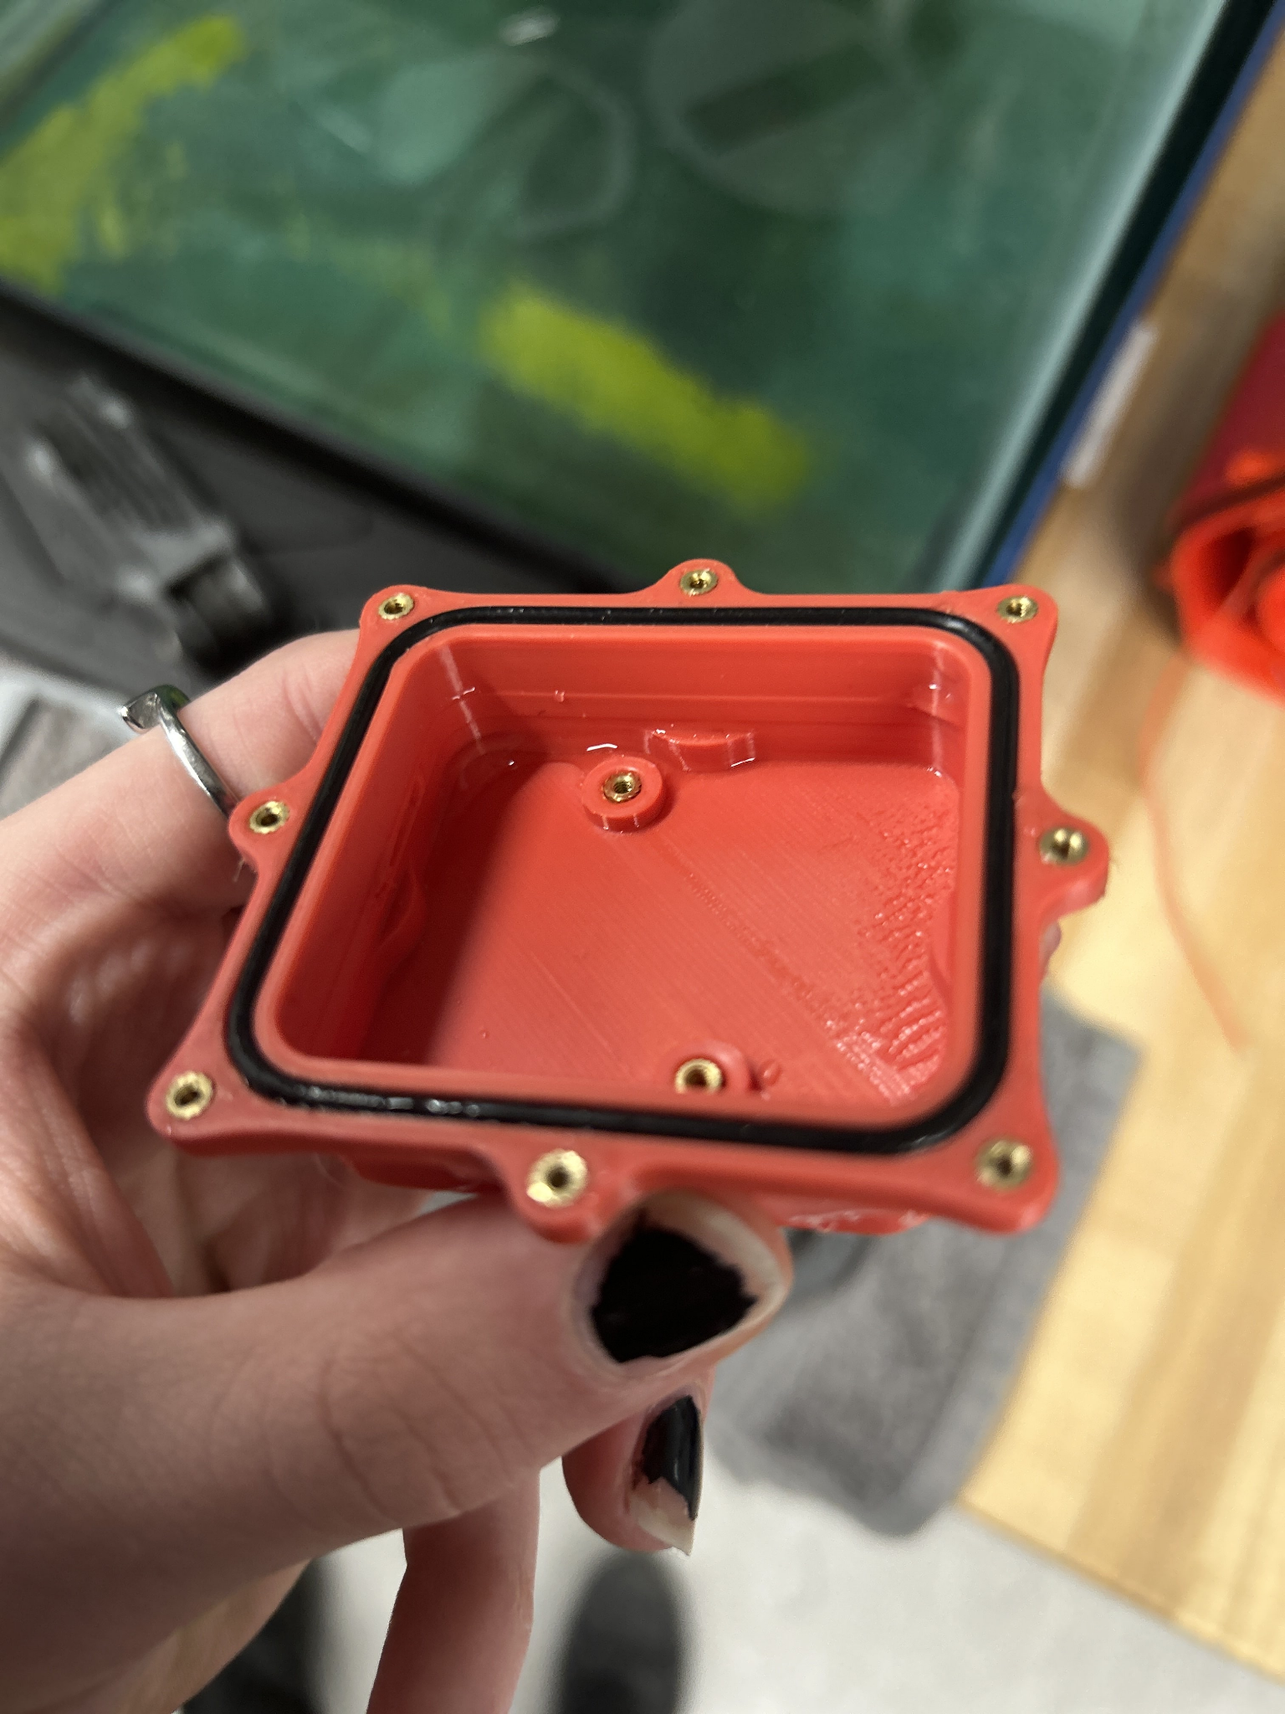

(*Figure C.12: inside of PCB housing immediately after first water test)*

Test 2

The hot glue was reinforced with more hot glue where bubbles were spotted, and washers were added to the screws to distribute the force more evenly across the seal. A string was then attached with a fishing weight so the housing could be left in the water for longer-term tests.

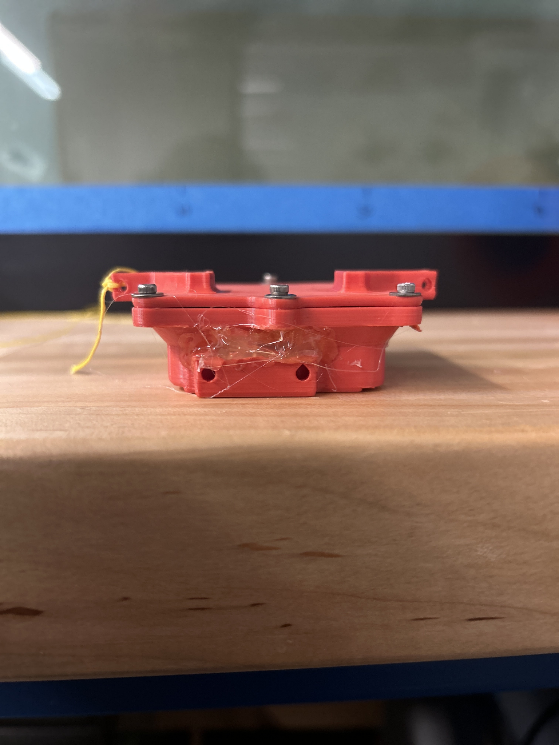

*(Figure C.13: picture of assembled PCB housing prepped for second water test)*

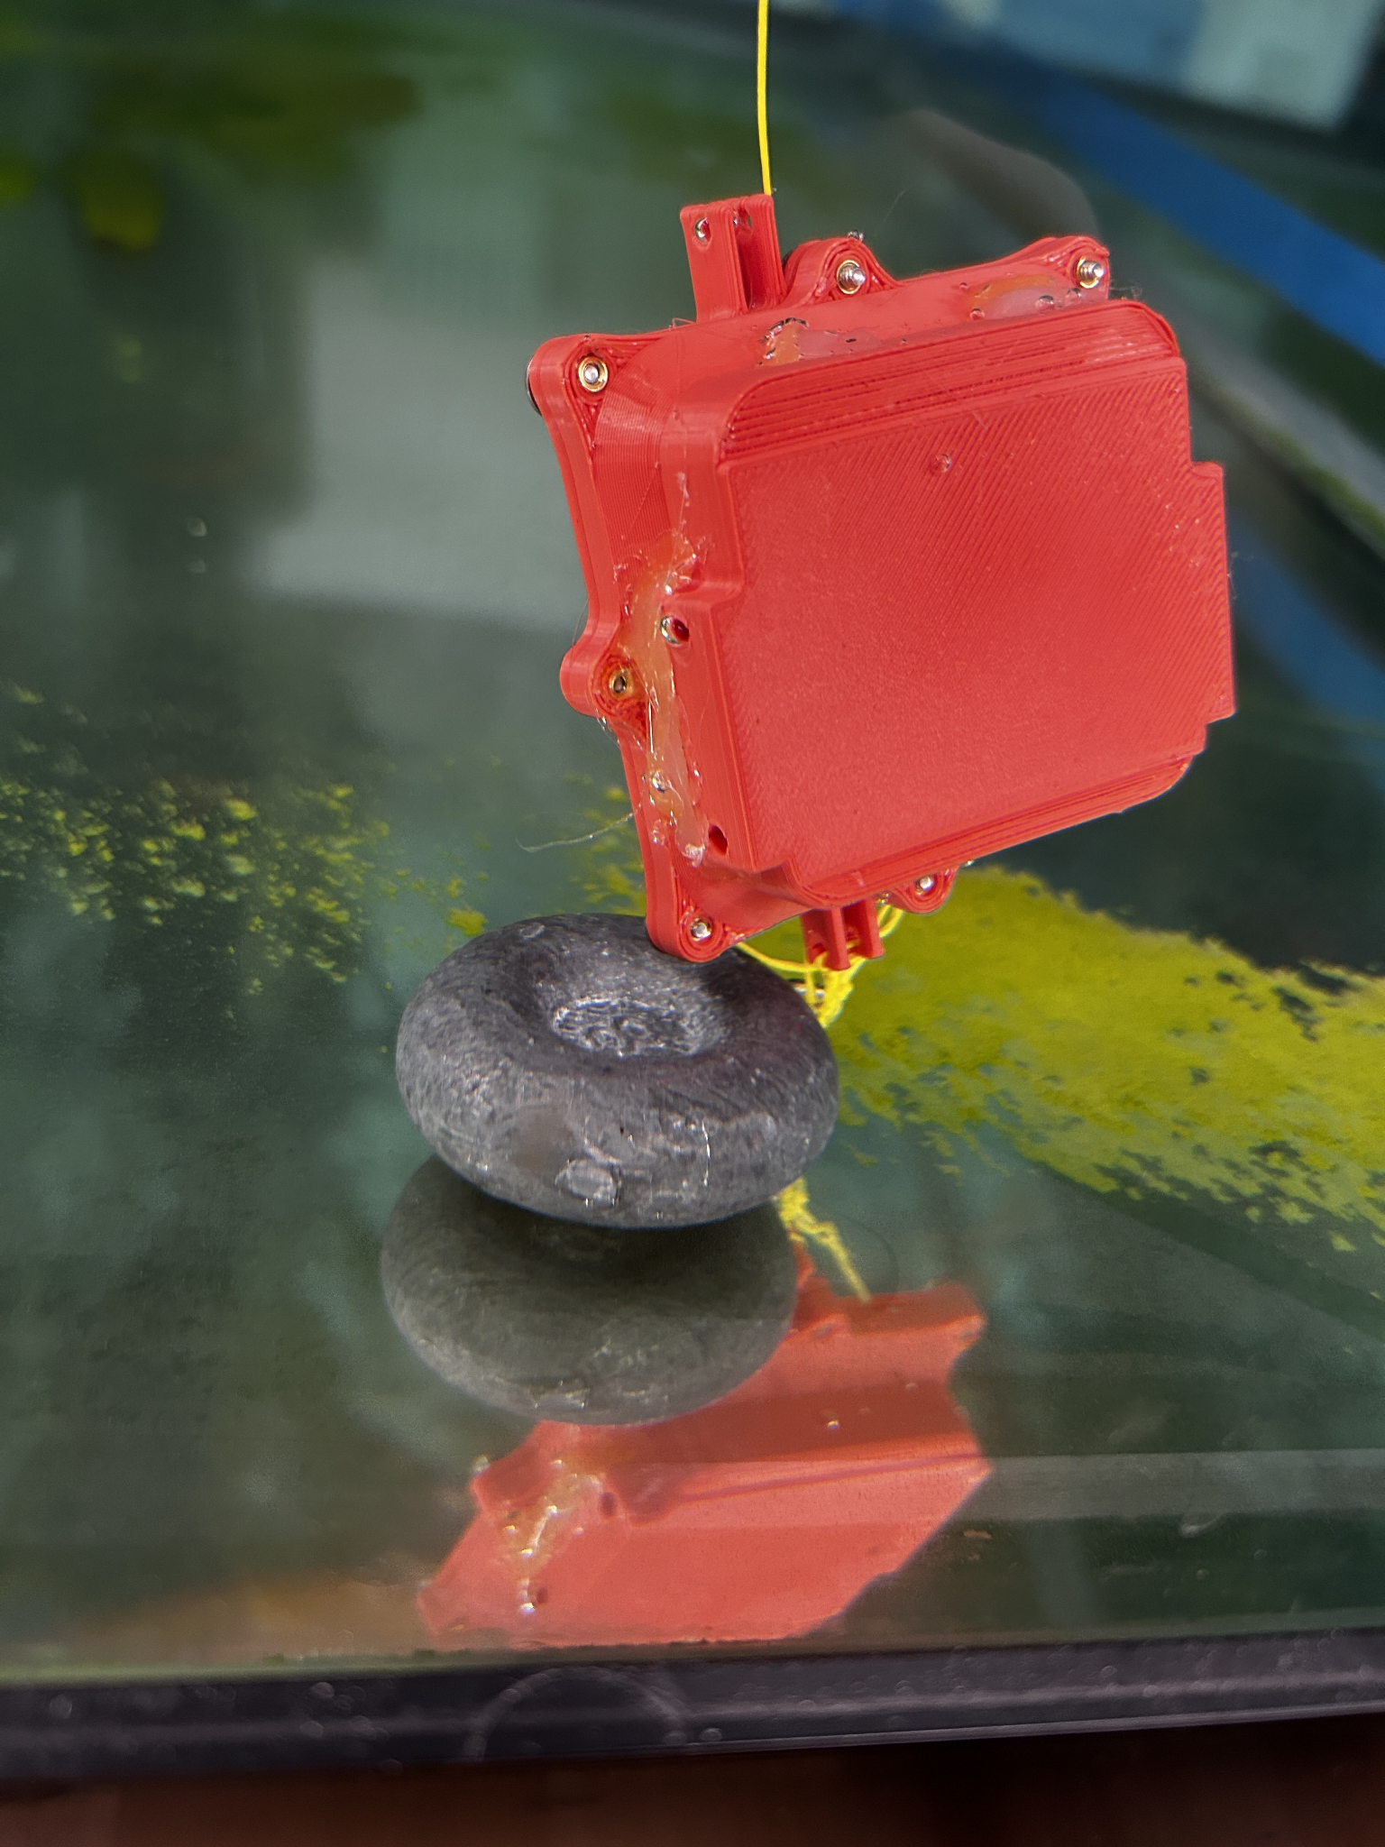

*(Figure C.14 Picture of the PCB housing water test being performed)*

Results:

Failure/inconclusive: Upon closer inspection than was performed during the first test, the lid deformed when attached. Once in the water, there were fewer bubbles but still bubbles coming from the seal, and there was some water inside when the housing was opened up. There also seemed to be bubbles coming from a section of the lid that could either have been coming from the lid itself (water seeping into the lid) or were coming from the seal near that part and just getting stuck on that part before being released fully.

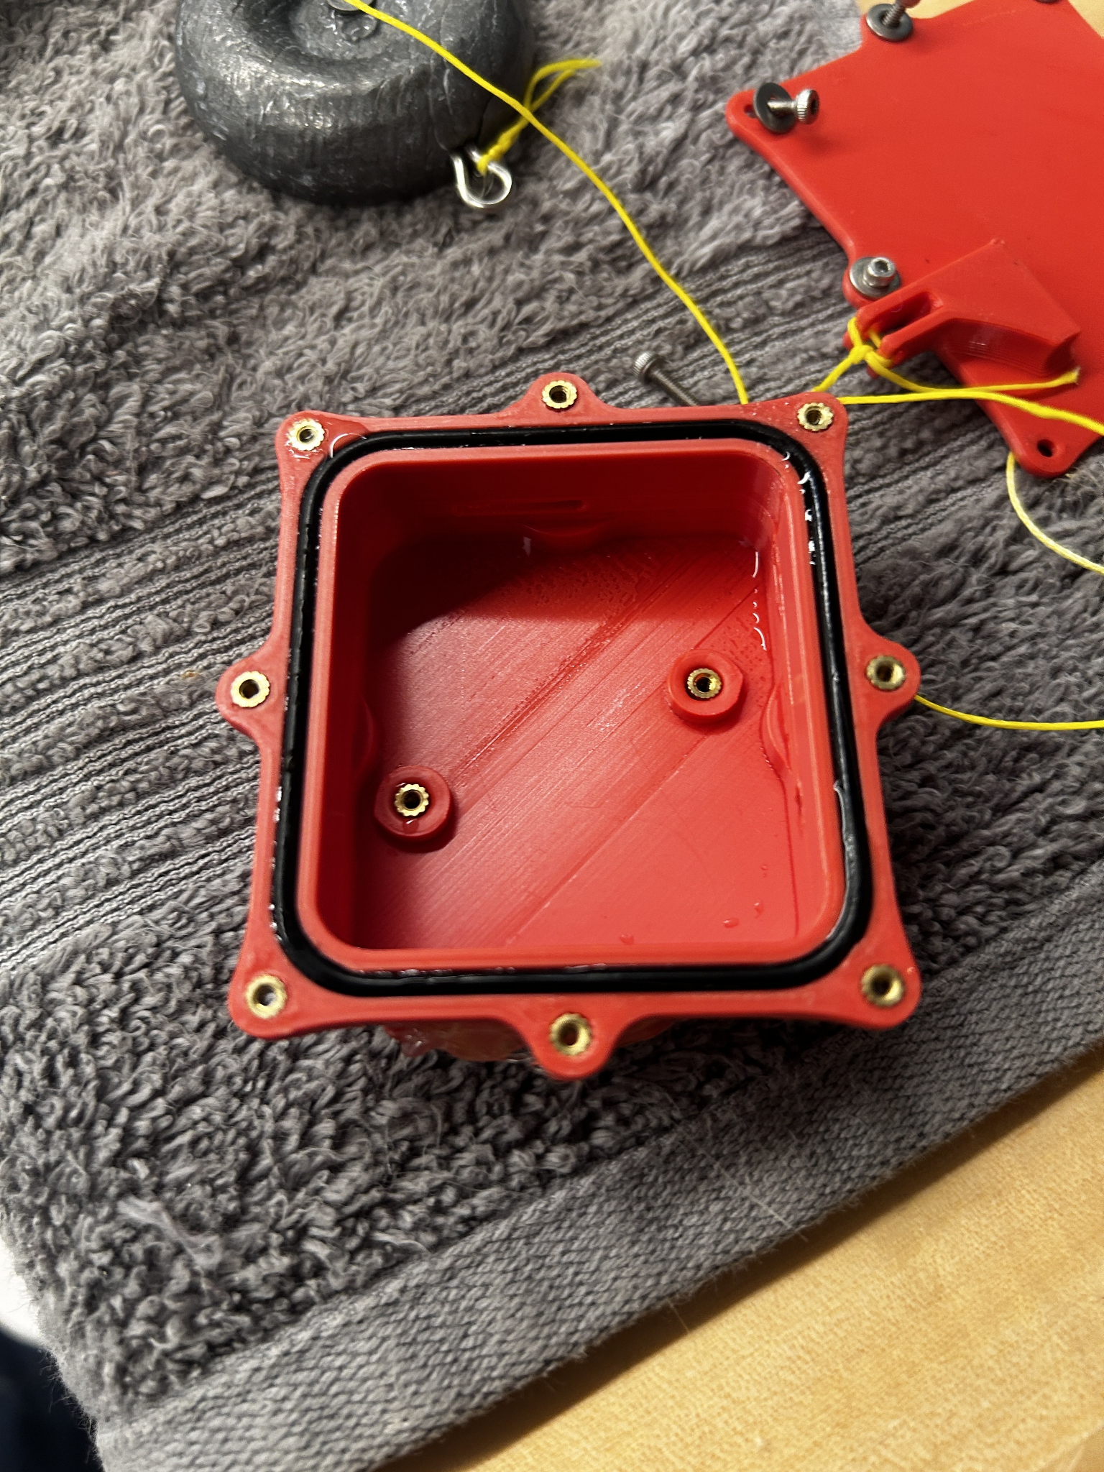

*(Figure C.15 Inside of PCB housing immediately after second water test)*

Conclusions:

The final part will be coated in a waterproofing coating that will prevent seepage through the PLA, and epoxy will be used to seal around the wires coming out of the box where hot glue was used during the tests, so the seal is the only part that is of any concern.

Lid deformation likely resulted in the seal not being properly compressed resulting in an imperfect seal which needs to be addressed:

* Increasing the lid thickness could help with rigidity but space is currently very limited. This could become more feasible after the PCB is redesigned.
* Increasing print rigidity
  + Higher infill%
  + More walls
  + More top and bottom full layers

The seal design could also be a problem. Other team members have utilized a lip/radial seal which may prove more effective.

The housing could also potentially be filled with silicone grease or any hydrophobic electrically insolating viscous fluid to further protect the PCB from slow leaks.

# 

# Pranav:

**Hex Caps:**

- After the MQP team decided to use the accordion as the body of the eel, the hex caps were created and improved to improve the efficiency of the eel.

- There are two main sides of the hex caps: the motor side and the passive side.

- The initial design had the following as the hex caps

| **Motor Side** | **Passive Side** |
| --- | --- |
|  |  |
| **Description:**  - Here, the string went from the passive side, through the holes in the accordion, to the motor side.  - As there were two holes on either side, a notch was added to the motor side to allow both the strings to come closer together, before going onto the pulley system. | |
| **Strengths:**  - The two strings were able to converge to a single string on either side, reducing the complexity of making two separate pulley systems for each set of strings. | **Weaknesses:**  - The notch had a lot of pressure from the strings as it was making 90 degree angles; this increased the tension within the string.  - The motor side hex cap wasted a lot of filament in supporting the base of where the motor will go.  - The motor side hex cap was relatively weaker and more prone to breaking. |

| **Motor Side** | **Passive Side** |
| --- | --- |
|  |  |
| **Description:**  - Looking at the previous design, the motor side was improved by adding more notches with angle difference of 30 degrees until it became 90 degrees.  - To reduce the filament wastage, the motor support was made into its own component.  - To test the best location of the motor, extra holes were added. | |
| **Strengths:**  - The tension in the string reduced significantly due to the added notches.  - The extra component significantly reduced printing time of the motor side hex cap and increased its strength. | **Weakness:**  - Even with a higher torque motor, the tension in the strings was still significant which reduced the rotation angle of the accordion. |

| **Motor Side** | **Passive Side** |
| --- | --- |
|  |  |
| **Description:**  - Looking at the previous design, the motor side was improved by removing the excess holes. | |
| **Strengths:**  - Removing the excessive holes allowed the motor hex cap to become thinner, allowing for more space in the middle for the other components | **Weakness:**  - Even with a higher torque motor, the tension in the strings was still significant which reduced the rotation angle of the accordion. |

| **Motor Side** | **Passive Side** |
| --- | --- |
|  |  |
| **Description:**  - Looking at the previous design, the passive design was altered to allow the strings to converge at the passive side rather than the motor side to reduce the tension in the strings.  - The motor side remained the same; however, the notches on the motor side weren’t utilized as the strings already converged before coming to the motor side. | |
| **Strengths:**  - The motor was able to spin the full 360 degrees; 180 degrees on either side, which allowed the accordion to turn large angles. | **Weaknesses:**  - As the motor was changing the direction quickly, the string kept popping off the pulley, reducing the length that the eel could run properly. |

| **Motor Side** | **Passive Side** |
| --- | --- |
|  |  |
| **Description:**  - Looking at the previous design, slots were added to the motor side to make a system to stop the strings from popping off. | |
| **Strengths:**  - The accordion was turning relatively well. | **Weaknesses:**  - The attachment of the string stopping component was difficult to tighten due to amount of space left after attaching all the other components.  - Due to the height of the slots, they were easier to break. |

| **Motor Side** | **Passive Side** |
| --- | --- |
|  |  |
| **Description:**  - Looking at the previous design, the slots were improved to create a snap the other component and be screwed in for extra strength.  - A slot was added above on either side for placing the I2C to PWM circuit. | |
| **Strengths:**  - The accordion is turning relatively well. | **Weaknesses:**  - Slots need to be changed with a sturdier design to keep the circuit in place. |

**Spools:**

- Using the previous design of the EEL as a stepping stone, the initial design had the following as the spool

| **Spool** | |
| --- | --- |
|  | |
| **Description:**  - Looking at the previous design, the holes were kept at either side of the spool.  - The size of the spool was increased as much as possible to reduce the amount that the spool needed to turn to get | |
| **Strengths:**  - Had good space between the holes to easily tie and untie the strings | **Weaknesses:**  - Can turn roughly 90 degrees on either side before both sides start pulling the string. |

| **Spool** | |
| --- | --- |
|  | |
| **Description:**  - Looking at the previous design, the holes were moved closer together and an angle was added inside the spool. | |
| **Strengths:**  - The string was more likely to stay in the middle of the spool | **Weaknesses:**  - Due to the spool changing direction relatively quickly, the string kept popping out. |

| **Spool** | |
| --- | --- |
|  | |
| **Description:**  - Looking at the previous design, the spool was made thinner and deeper to reduce the possibility of the string to come out | |
| **Strengths:**  - | **Weaknesses:**  - The string was relatively stuck inside the spool.  - Increasing the depth increased to angle that the spool needed to turn to bend the accordion |

| **Spool** | |
| --- | --- |
|  | |
| **Description:**  - Looking at the previous design, the spool was put back to the same thickness as before.  - A beam was added on either side to stop the string from popping | |
| **Strengths:**  - Stopped the string from popping relatively well. | **Weaknesses:**  - The beams stopped the spool from turning 180 degrees on either side |

| **Spool** | |
| --- | --- |
|  | |
| **Description:**  - Looking at the previous design, as external string stoppers were added, the added beams were moved closer to tie the strings on.  - The holes were replaced with beams to stop the string from interfering with the string stoppers. | |
| **Strengths:**  - Stopped the string from popping off relatively well. | **Weaknesses:**  - The spool size could increase slightly more. |

### 

# Natalie:

### **Troubleshooting 3D Printing Issues for EEL MQP**

**Objective** To 3D print several flexible accordions out of soft filament. This report consolidates all documented challenges, adjustments, and breakthroughs during the 3D printing process. It highlights material testing, hardware solutions, and iterative improvements to overcome failures and achieve functional prototypes.

### **Timeline of Challenges and Solutions**

#### **Initial Troubleshooting (November 18th–December 2nd)**

1. **Nozzle Clogging and Maintenance**
   * **November 18th**: Frequent nozzle clogging on the Taz printer required hot and cold pulling methods for clearing, with limited success.
   * **November 19th**: Ordered a replacement **Microswiss 0.5mm nozzle** and identified filament obstruction as the likely root cause.

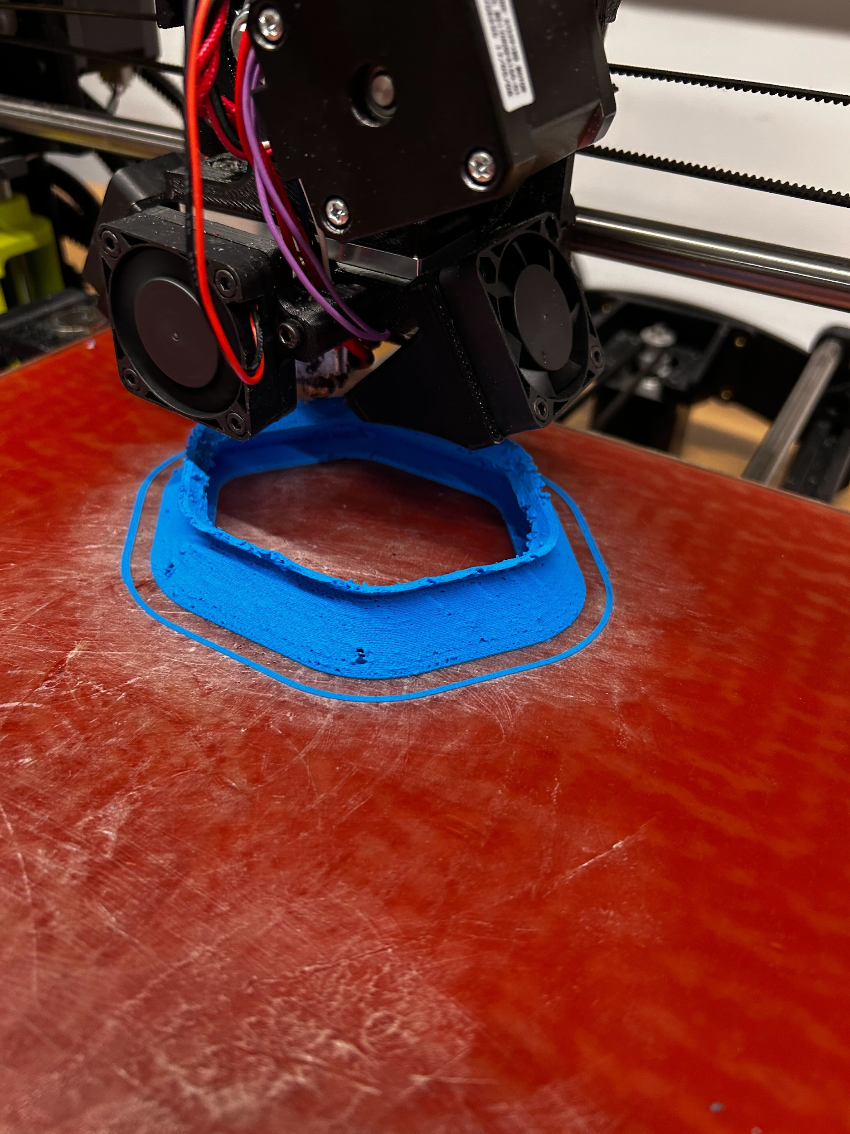

1. **Material Obstructions**
   * Noticed a **sticky, greenish extrusion** from Chinchilla filament, which failed to harden properly. This material was deemed unsuitable for use in the project.

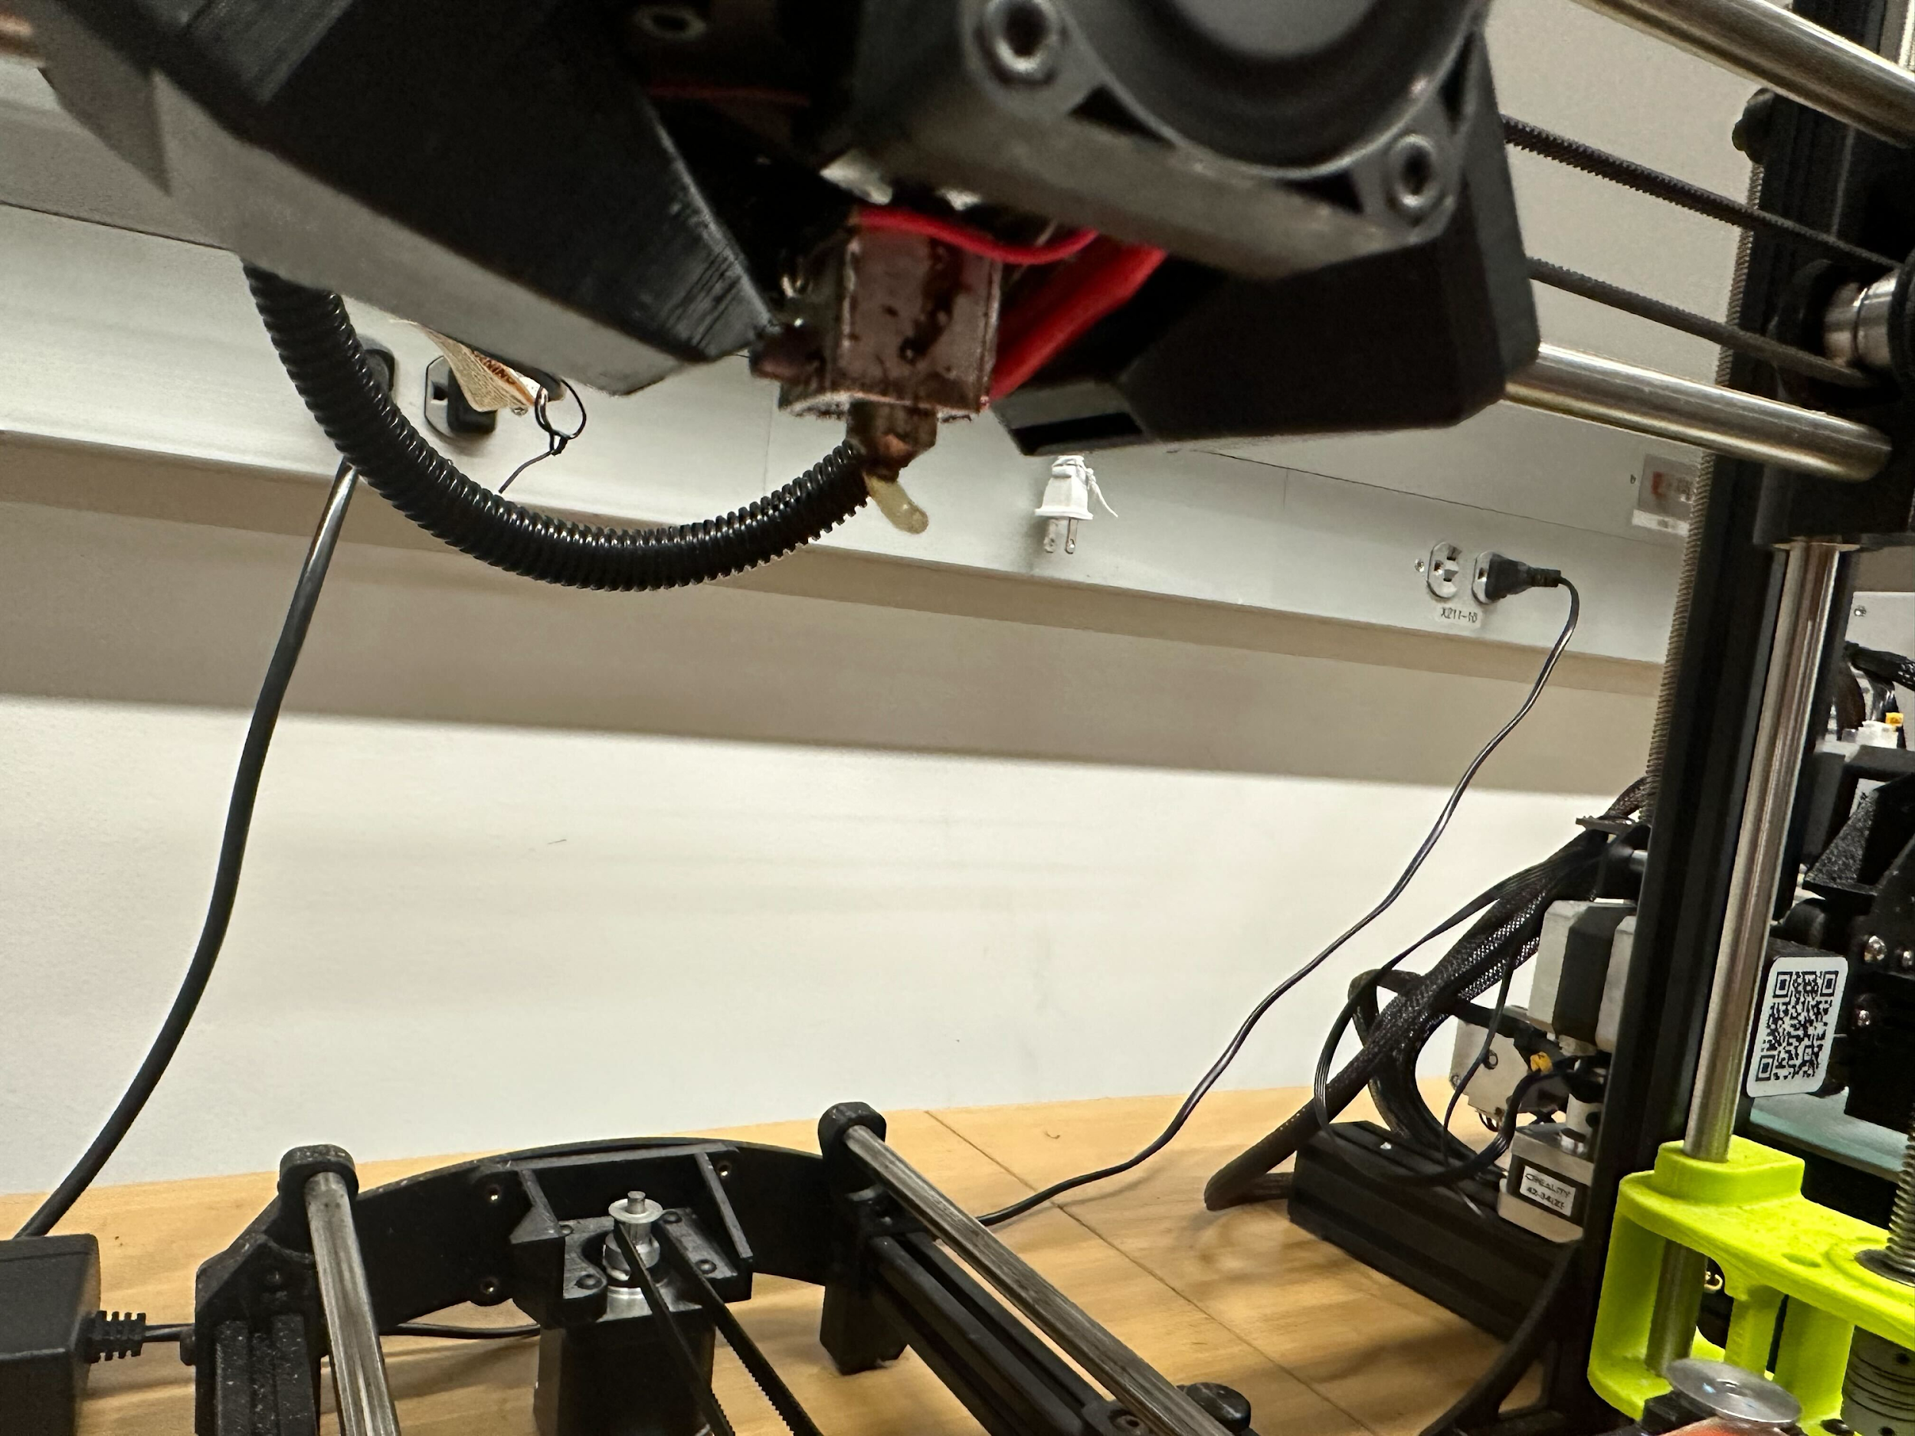

#### **Material Failures and Early Testing (December 3rd–5th)**

1. **Initial Print Failures**
   * **December 3rd**: Early attempts produced poor quality prints with failed adhesion and structural inconsistencies. The filament’s exposure to humidity was identified as a potential issue.
   * Used a filament dryer to reduce moisture and observed some improvement.
2. **Nozzle Replacement and Promising Results**
   * Replaced the nozzle, which led to initial signs of improvement.
   * Purchased spare nozzles and glue sticks to ensure future operational efficiency and reduced downtime.
3. **Further Failures and Adjustments**
   * **December 5th**: Continued testing different printer settings and nozzle adjustments. While progress was made, extrusion issues and adhesion failures persisted.

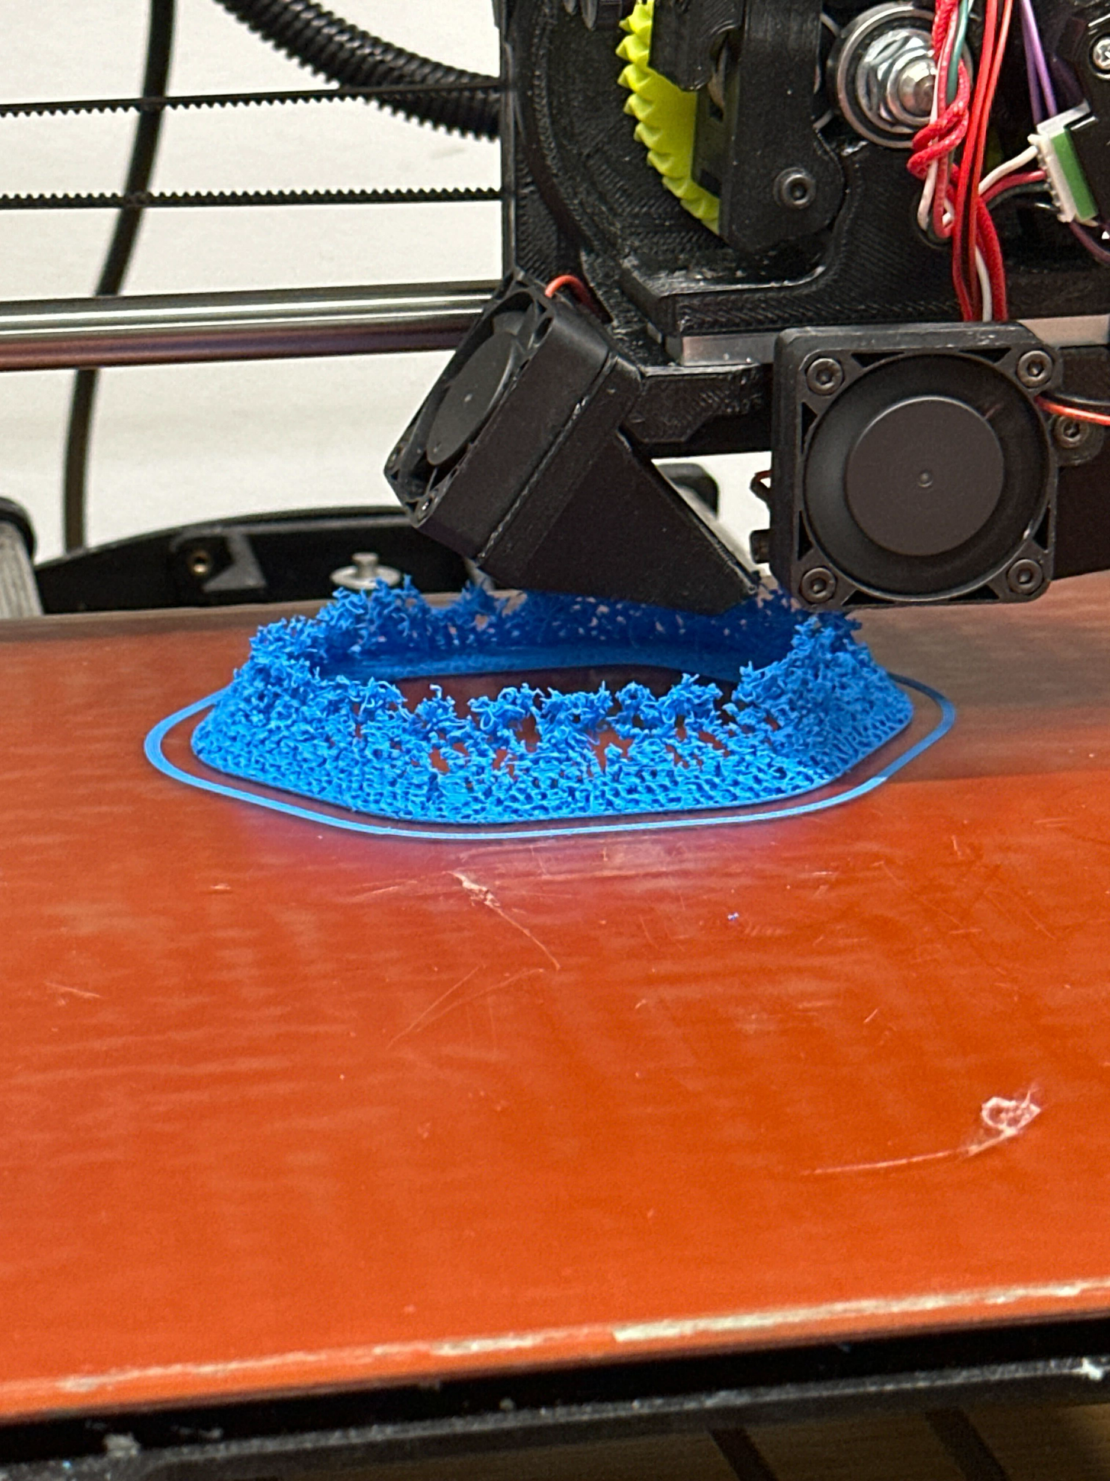

#### **Breakthroughs and Successful Prototypes (December 6th–9th)**

1. **Switch to Alternative Materials**
   * **December 6th**: Transitioned to **NinjaFlex filament**, which adhered effectively and printed successfully on the first attempt.
   * Successfully printed a **tail prototype** using Ninjaflex TPE material, marking significant progress toward project completion.

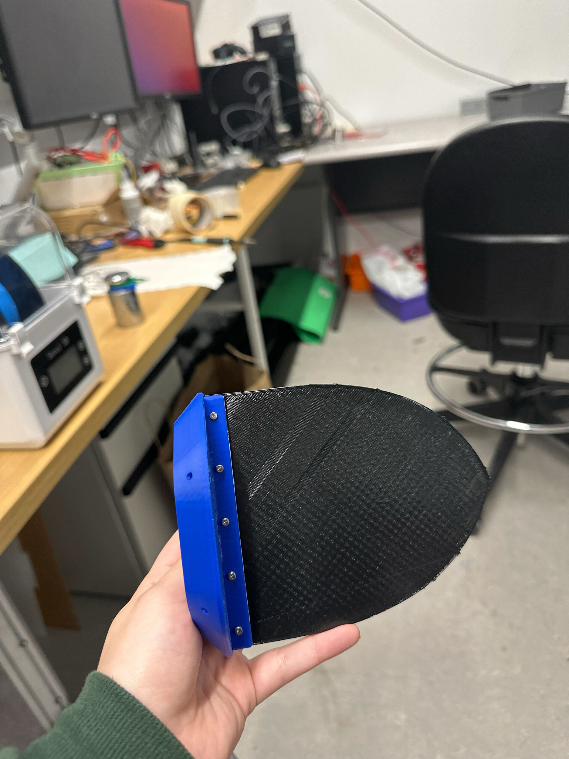

1. **Accordion Component Fabrication**
   * **December 9th**: Successfully printed functional accordion structure using Ninjaflex TPE material, marking significant progress toward project completion.

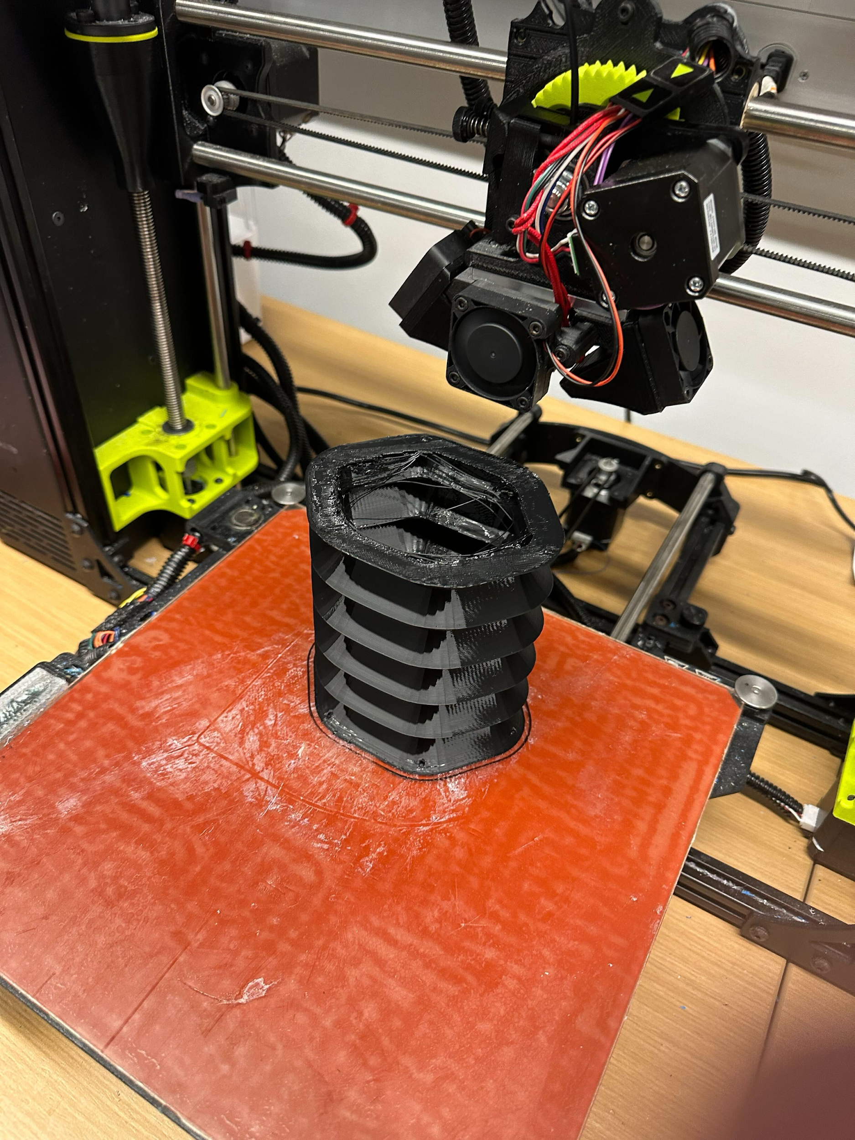

1. **Celebrating Success**
   * Documented the successful prints and shared results with collaborators, validating the team’s troubleshooting efforts.

### **Key Challenges and Resolutions**

1. **Persistent Print Failures**
   * **Cause**: Humidity in filament, nozzle clogging, and incompatible materials.
   * **Resolution**: Dried filament, replaced nozzles, and tested alternative materials like NinjaFlex TPE.
2. **Material Quality Issues**
   * **Problem**: Sticky, gummy Chinchilla filament failed to harden.
   * **Resolution**: Discontinued Chinchilla filament in favor of NinjaFlex, which demonstrated superior performance.
3. **Hardware Issues**
   * Repeated nozzle clogging and extrusion inconsistencies necessitated cleaning, adjustments, and eventual nozzle replacement.
4. **Team Collaboration**
   * Encouraged better organization and communication regarding spare parts and supplies for efficient troubleshooting.

### **Recommendations for Future Work**

1. **Material Storage**
   * Store filament in a **humidity-controlled environment** to maintain quality and consistency.
2. **Printer Maintenance**
   * Regularly clean and inspect nozzles, extrusion paths, and gears to ensure consistent performance.
3. **Collaborative Workflow**
   * Maintain a well-organized inventory, share troubleshooting documentation, and foster open communication for effective teamwork.
4. **Iterative Prototyping**
   * Perform small-scale tests with new materials before committing to larger prints to save time and resources.

### **Conclusion**

This report outlines the iterative and collaborative approach to solving 3D printing challenges, emphasizing the importance of material selection, hardware maintenance, and teamwork. Despite a great number of setbacks, the team successfully fabricated the accordions and tail component using Ninjaflex TPE. These insights will guide future efforts and contribute to the overall success of the college project.

# 

# Dexter:

## Head

### Overview

To allow our robotic eel the ability to control its motors and retain data from its sensors, a module needed to be created that could safely house the sensors and keep the main control boards dry. This module would sit at the front of the eel and act as its head. In the making of the first few digital models, the goal was to cement the idea for a rough shape for what would later become the end result. These iterations began as one long head separated by internal dividers to prevent leakage onto critical components, with the outside shape gradually shifting from an oval to a horizontally compressed hexagon. This shape allows for increased aerodynamics while also simplifying the process of creating the connection between the head and the rest of the body, as the body maintains the hexagonal shape.

### Control Compartment

So far, two iterations of the back portion of the head have been printed. This back half is meant to house the control boards used to read data from the sensors as well as provide the main source of control for the motors. In order to keep these safe, the containment section would need to be watertight. A ridge was created around the edge of the containment area and sealed with a rubber O-ring to aid in this process. To test the effectiveness of this design, each iteration was closed and held underwater to check for bubbles. The first prototype managed to stay completely dry on the inside, while the second allowed for a few drops of water to enter. Later versions will have sealant on the outer edges and an improved seal shape to hopefully prevent any further leaks.

Cover and compartment of iteration 1:

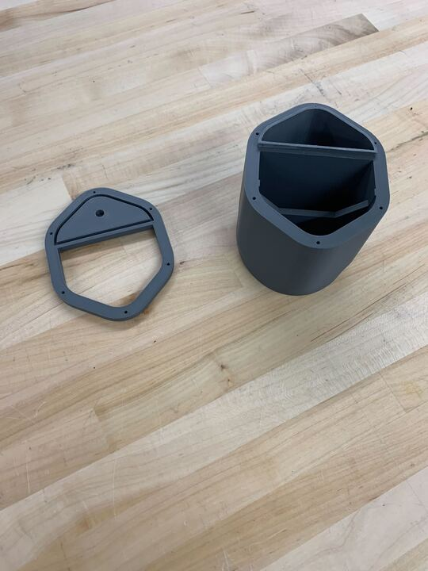

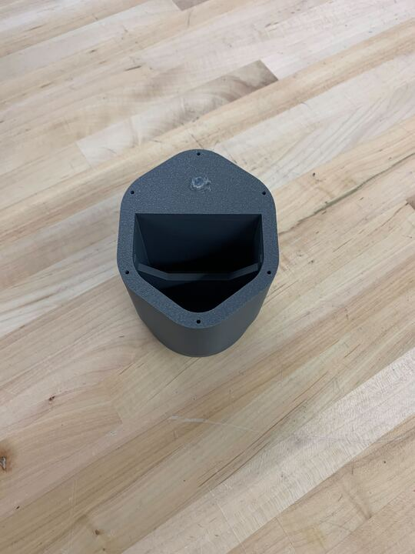

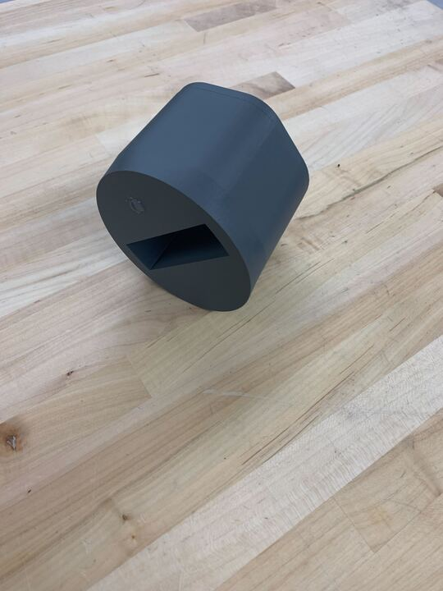

Cover and compartment of iteration 2

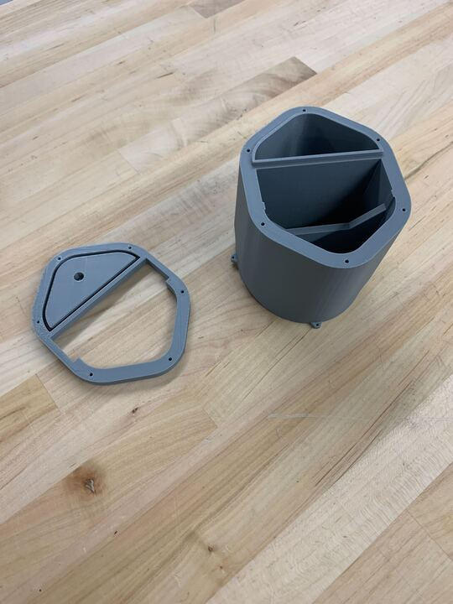

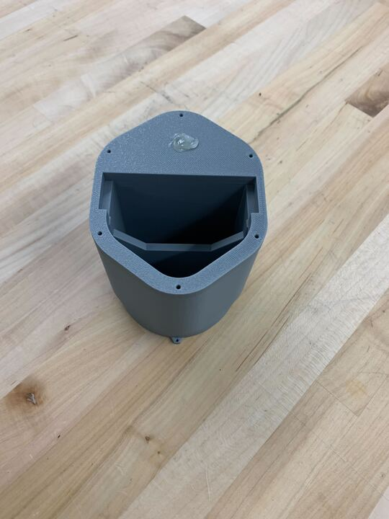

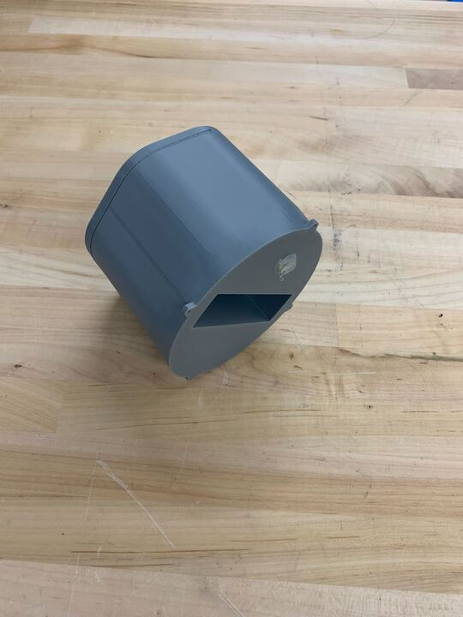

### Sensor Compartment

While no physical prototype currently exists, the front section of the head is still being designed. The hope is that this portion will contain the battery and all of the sensors needed to both control the eel and collect data. The proposed sensors included in this are a microphone (used to receive control signals in the form of sound waves), 2 sonar sensors (one for obstacle detection and one for data collection), and a depth control sensor. Since this section is not currently critical for creating a working prototype for the whole eel, it will be worked on further at a later point.

Cad model of the current design for the sensor compartment:

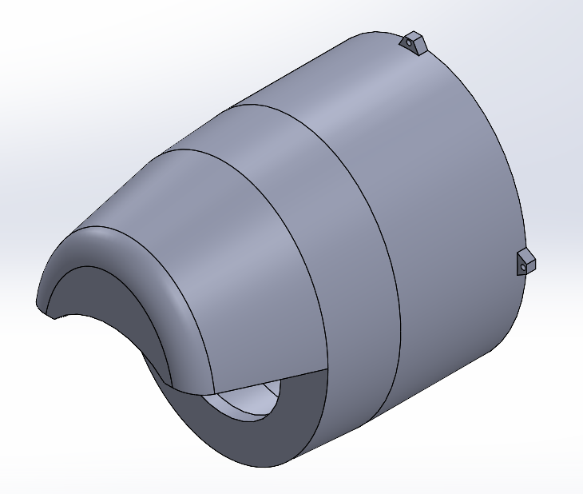

### Challenges

So far, there have not been too many challenges while working through this process. The only thing that has caused any setbacks up to this point has been having to modify the overall shape in order to keep up with the current design of the other modules. This has slowed down over time as the base shape and measurements of the eel have come closer to being finalized.

### Conclusion

Moving forward, more improvements to each section of the head are needed to ensure the proper functionality of the whole project. More tests and tweaks will need to be done to ensure that it remains watertight, and changes are in the works to allow a more secure connection to the rest of the body. Some of the proposed enhancements for the waterproofing are to create a tighter seal around the outer edge of the cover and to increase the amount of pressure applied to the O-ring on the inside. This will be done through the addition of screws on the outside and inside edges of the compartment, which will also serve to evenly distribute the pressure applied to the O-ring. More research may need to be done to conclude the best possible way of keeping water out of the compartment, but could also be unnecessary considering its overall success so far.